# Sustainability Commission

## March 17, 2015

## 4:00 p.m. to 5:30 p.m.

**City of Franklin – Community Development Room – City Hall**

|  |  |  |
| --- | --- | --- |
| 4:00 p.m. | **Call to Order/Introductions** | LK Browning |
| 4:05 pm – 4:10 pm | **\*Approval of Meeting Minutes** | LK Browning |
| 4:10 pm – 4:30 pm | **Announcements:** *Parking Garage Lights 1 MW Solar Update PACE Update Solar Tax | Andrew Orr |
| 4:30 pm – 5:00 pm | **Goals for the year** | All |
| 5:00 pm – 5:15 pm | **Other News/Adjourn** | LK Browning |

*Item contains an attachment or link

**MISSION STATEMENT:** The Sustainability Commission provides guidance to the Board of Mayor and Aldermen and the Planning Commission and leadership for the entire Franklin Community.

*The City of Franklin has committed itself to developing an ongoing strategy of sustainability for the community. This initiative will be designed to achieve viable, fulfilling, and rewarding lifestyles for our residents and business partners through responsible and innovative stewardship of the environment.*

**MINUTES OF THE MEETING OF THE**

**FRANKLIN SUSTAINABILITY COMMISSION**

**OCTOBER 21, 2014**

The Franklin Sustainability Commission held a regular meeting on Tuesday October 21, 2014, at 4:00 p.m., in the Community Development Conference Room.

**Members Present**: Teresa Ashworth-Harris, Chair L.K. Browning, Vice Chair Matt Bryant,

Mathue Bean, Brian Miller, Bob Moreo, Mayor Ken Moore, Ken Scalf

**Members Absent:** Miles Mennell

**Visitors Present:** Michael Ackley

**Staff Present**: Paul Holzen, Andrew Orr, Brenda Woods

**Call to Order/Introductions**

**Approval of Meeting Minutes**

**Chair Browning** presented the September 16, 2014, minutes for consideration.

**Mr. Moreo** moved to approve the September 16, 2014, minutes, Mr. Miller seconded the motion, and the minutes were unanimously approved (8-0).

**Comprehensive Transportation Plan Overview**

**Mr. Holzen** gave a PowerPoint presentation regarding the City of Franklin Comprehensive Transportation Network Plan (CTNP).

**Vice Chair Bryant** asked when the CTNP was expected to be completed.

**Mr. Holzen** stated in 1 1/2 years.

**Mayor Moore** stated that this would correlate with the 2040 plan, and he asked if that was being taken into consideration.

**Mr. Holzen** stated that it was.

**Vice Chair Bryant** asked if this would replace the Capital Improvement Plan.

**Mr. Holzen** stated that it would replace the Major Thoroughfare Plan.

**Mr. Orr** asked about the sidewalks on Highway 96 East and Highway 96 West.

**Mr. Holzen** stated that there would be sidewalks to Pinkerton Park and that the City of Franklin was getting ready to have some state help.

**Mr. Scalf** asked about Mack Hatcher Parkway.

**Mr. Holzen** stated that it was being designated as a four-way highway.

**Mr. Holzen** discussed multi-use trails.

**Ms. Ashworth-Harris** asked how they would be built.

**Mr. Orr** asked about Aspen Grove and the connection to Mack Hatcher.

**Mr. Holzen** stated that it was not the City’s top priority, but they were trying to get an 80/20 match.

**Mayor Moore** stated that Columbia Avenue had recently received an 80/20 match. It will be funded at 100 percent on Columbia Avenue to Downs Boulevard.

**Mr. Moreo** asked how the City was deciding about land use.

**Mr. Holzen** discussed the roadway.

**Vice Chair Bryant** asked how this would tie into Williamson County.

**Mr. Holzen** stated that the City coordinated with Williamson County. He stated that Concord Road would be widened to Moore’s Lane.

**Vice Chair Bryant** stated that he thought it was great that the City of Franklin had a comprehensive plan and was trying to tie it all together.

**Announcement**

* **TREEDC Conference Recap**

**Mr. Orr** stated that the TREEDC conference was held on October 12-14 in Cookeville, TN and was a success. TREEDC is trying to connect Tennessee to the Philippines and has been successful in dialoging.

* **Parking Garage Lights**

**Mr. Orr** stated that the new lights are performing well.

* **1 MW Solar Update**

**Mr. Orr** stated the environmental approvals are wrapping up.

**Mr. Scalf** discussed a new bio-faced material, which he will email to the Sustainability Commission.

* **PACE Update**

TDEC has a grant and they are investigating on behalf of the state.

**December/January Meetings**

**Mr. Orr** stated that the December meeting would be similar to this meeting regarding Mr. Holzen discussing the Comprehensive Transportation Plan Overview. Lisa Clayton, Parks Director will be invited.

**Mr. Orr** stated that there would not be a January Sustainability Commission meeting.

**Chair Browning** asked if the Commission wanted to have a social gathering. She would be happy to host one, again, as she did before. She would be happy to host it on Martin Luther King’s day.

**Mr. Orr** will email an invitation to the Commission members.

**Chair Browning** suggested skipping the November and January Sustainability meetings and having a December meeting.

**Mr. Orr** will let the Commission members know about the December meeting in the next few days.

**Other News/Adjourn**

**Mr. Orr** stated that TDEC has a clean energy grant with a 50/50 match that we will apply for, likely to pursue funding for 2nd Ave LED parking garage lights.

There being no further business, the meeting adjourned.

**Case Study: 4th Ave Parking Garage LED Conversion**

**City of Franklin, TN**

**Completed July 2014**

­

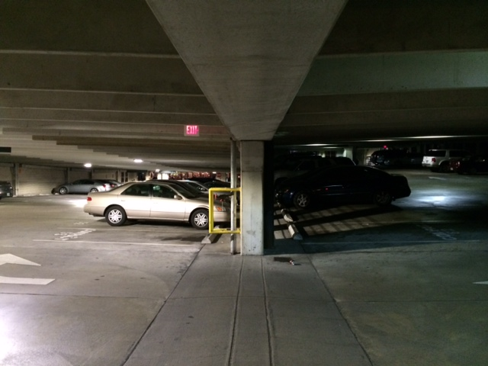

The 4th Ave parking garage is a free public parking facility in Downtown Franklin owned by the City. It serves the adjacent courthouse and the local businesses. The garage was built in the early 2000s. The lighting upgrade was initiated by City staff because of the poor light quality and desire to reduce electricity usage. This is a highly used garage and the lack of windows on the east side made the garage very dark. The photograph shows the new LEDs on the left side compared to the existing metal halides on the right.

* 4 level parking structure
* 86 light fixtures
* Retrofitted 175 watt metal halides to LEDs

Pre Install

Post Install

In FY 2013, $32,000 was budgeted to purchase and install LED lights. The City sampled several LED and induction fixtures. Still uncertain, the City reached out and received free assistance from Design Light Consortium (DLC) for a recommendation. The City then tested the Lithonia DSXPG and thought it would be a great application for this garage. Instead of a traditional RFP route, the City purchased the lights from Graybar via US Communities, an online prequalified procurement service which streamlined the competitive bid process. The lights have a five year warranty.

The project is a little unique because the garage was dimly lit. Staff purchased and installed 8 additional lights for the darker areas of the garage. The original lights were also placed high between the beams so light dispersal was a problem. To mitigate this and improve light distribution, the City purchased mounting plates and lowered the lights. The City’s Streets Department installed the lights over the course of two nights.

* Before conversion, average monthly electric utility cost=$1,050 (8-10 lights were burned out at any given time).
* After conversion, average monthly electric utility cost=$750 (City installed 8 additional lights).

Lessons Learned: Choosing the right LED was difficult because there are so many companies with each claiming to have the best light. Once the City decided on the Lithonia DSXPG, staff selected the light color, brightness, the color of the fixture, and declined other add-ons so the decision making process was fairly complicated. Staff found the advice from Design Light Consortium to be valuable.

Next Steps: The City owns another free public parking garage on 2nd Avenue in Downtown Franklin that is very similar to this one and seeks to use **Clean Tennessee Energy Grant** funds to convert the existing metal halides to LEDs.

Attachments: Photographs and specifications are attached.

Project Contact: Andrew Orr, Principal Planner with the City of Franklin; [Andrew.orr@franklintn.gov](mailto:Andrew.orr@franklintn.gov) or 615-550-6741

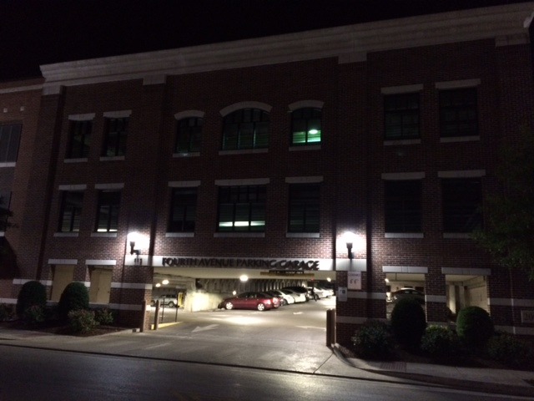

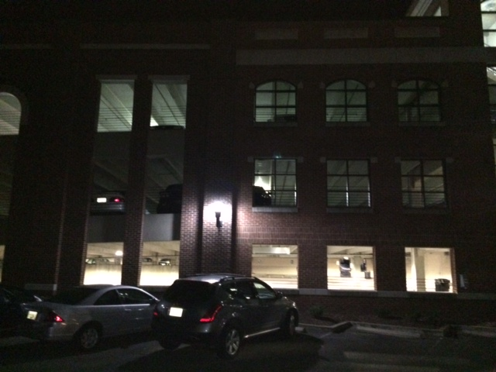

Both photos above show the garage during the installation. The new LEDs have been installed on the bottom level with the old metal halides on the upper levels.